# Project Development Phase

**Delivery of Sprint - 3**

|  |  |
| --- | --- |
| **Date** | 19 November 2022 |
| **Team ID** | PNT2022TMID27784 |
| **Project Name** | AI-based discourse for Banking Industry |

**Creating Loan Account Action**

Loan action is created with the necessary steps.

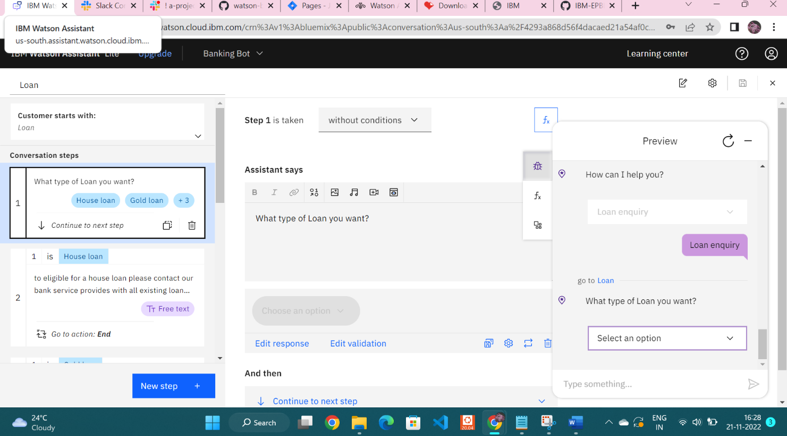

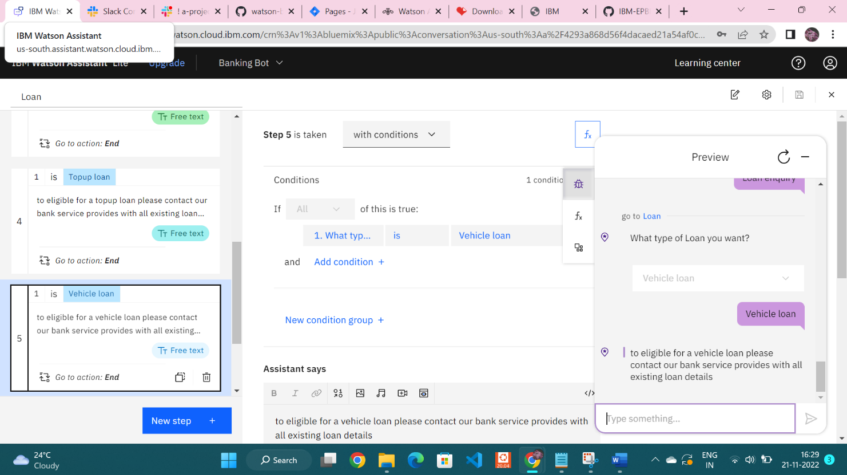

**Creating General Query Action**

General query action is created with the necessary steps.

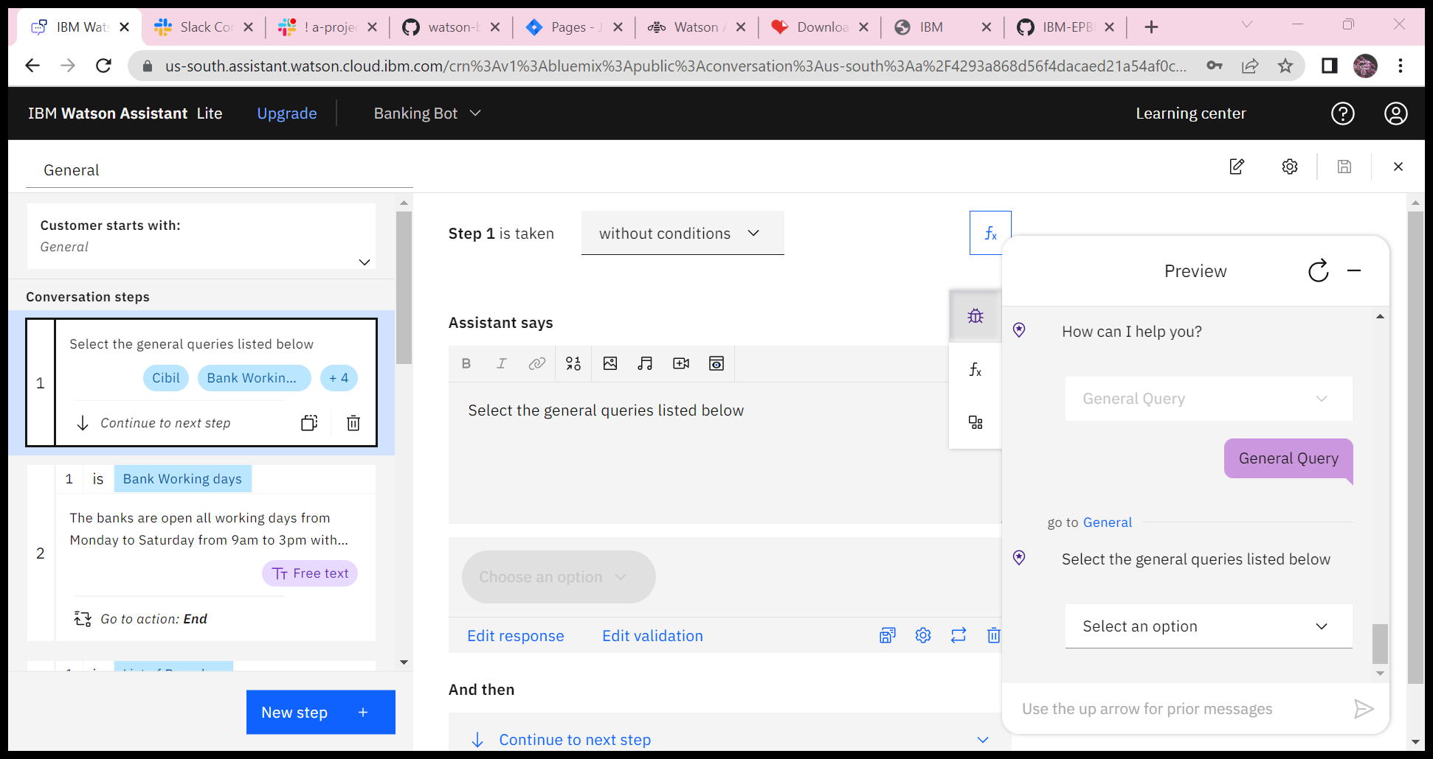

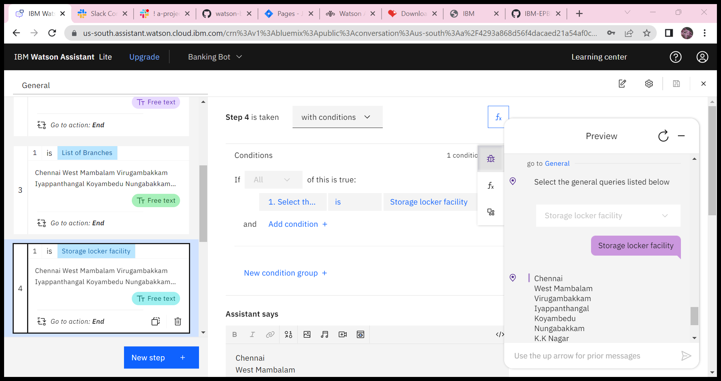

**Creating Net Banking Action**

Net banking action is created with the necessary steps.

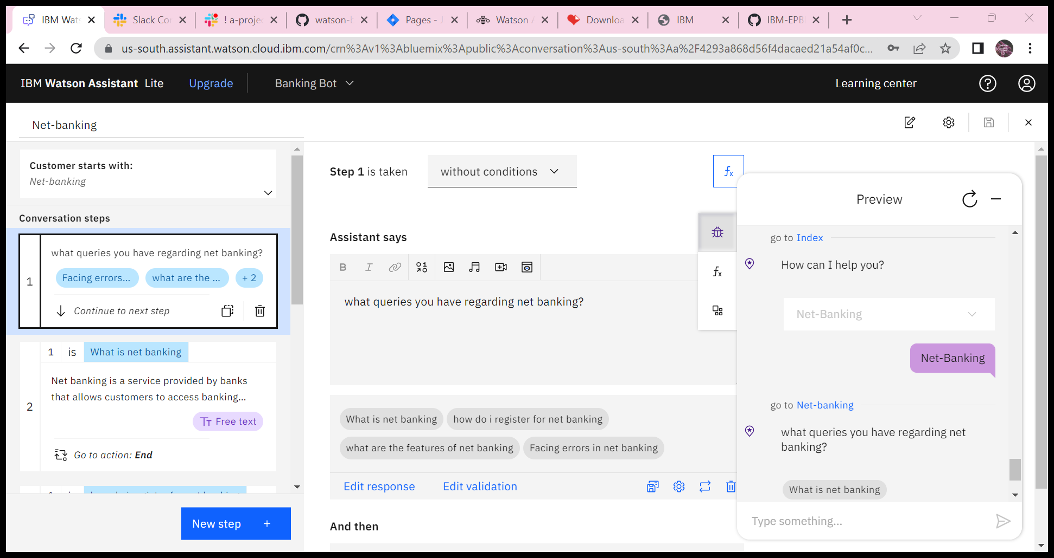

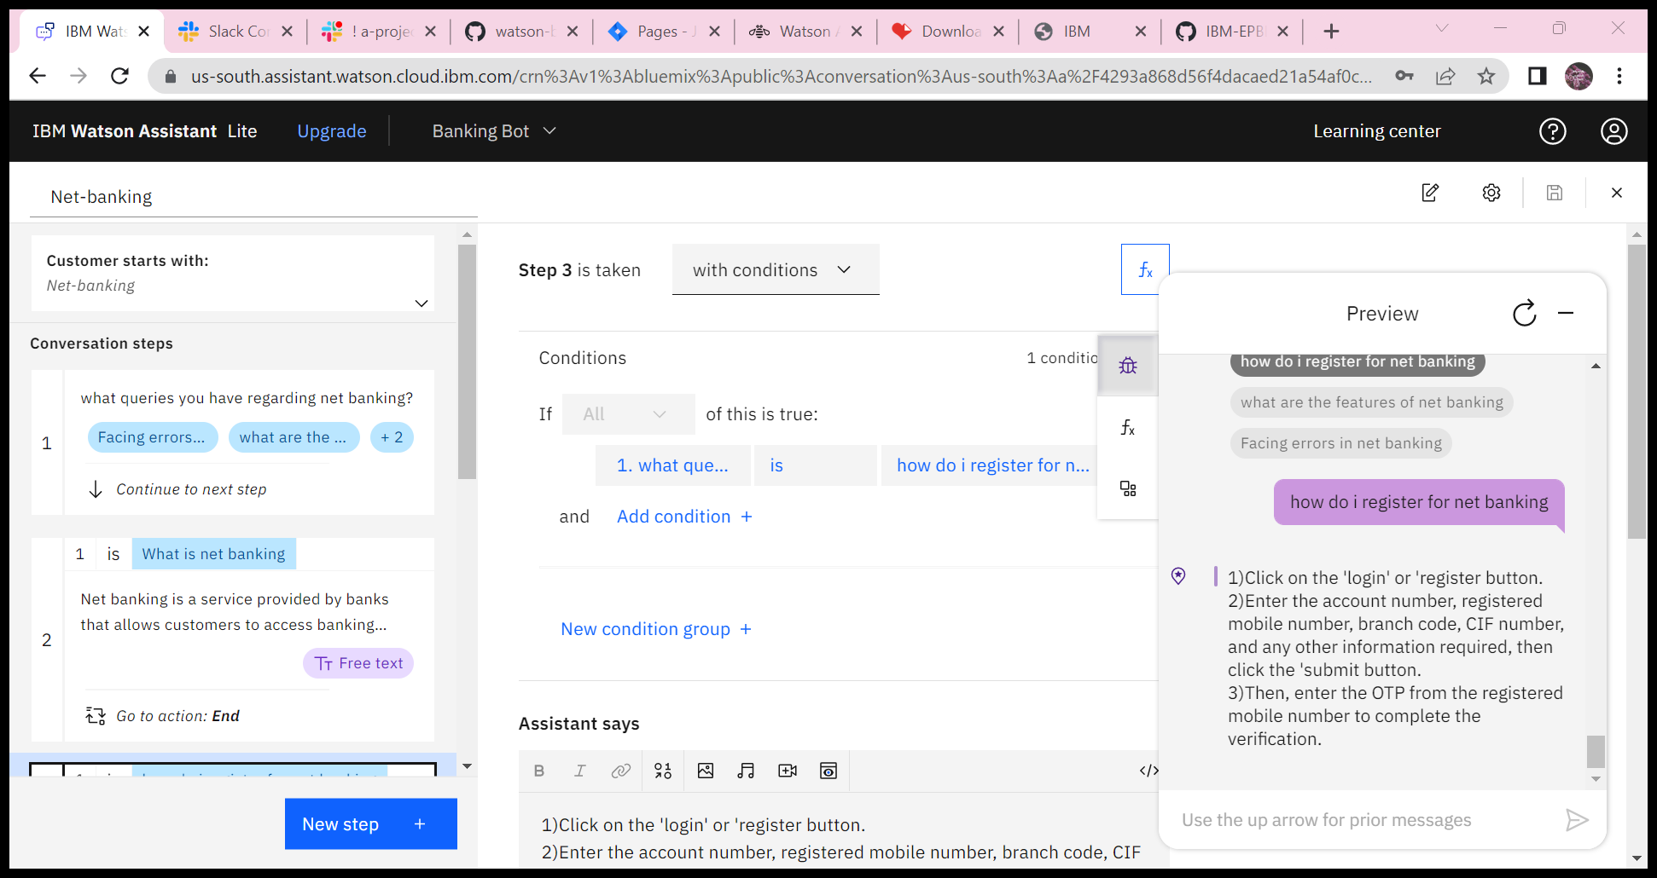

**Note:** No code for this project. So, I attached the screenshot and step to build it.